15.10.21
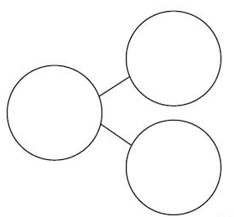
Can I add together?
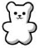
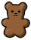
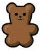
There are ______ brown bears.
There are ______ white bears.
There are ______ bears altogether.

_______ + _______ = _______ _______ + _______ = _______
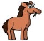
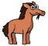
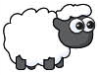
There are ______ horses.
There are ______ sheep.
There are ______ animals in total.
_______ + _______ = _______ _______ + _______ = _______

_______ = _______ + _______

Draw counters to show the objects.
There are 8 yellow sweets and 0 green sweets. How many sweets are there altogether?
_______ + _______ = _______ _______ + _______ = _______

_______ = _______ + _______ _______ = _______ + _______
There are 3 blue cars and 6 red cars. How many cars are there in total?

_______ + _______ = _______ _______ + _______ = _______

_______ = _______ + _______ _______ = _______ + ______
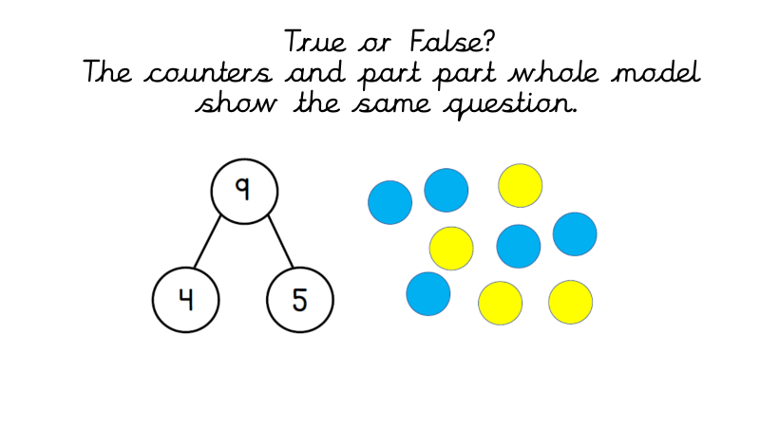
________________________________________

________________________________________

________________________________________

________________________________________

____________________________________________________________________________________________

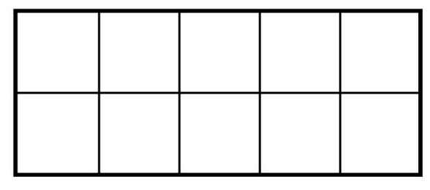

________________ red and ________________ yellow

________________ red and ________________ yellow

________________ red and ________________ yellow

________________ red and ________________ yellow

________________ red and ________________ yellow

________________ red and ________________ yellow

