13.10.21
Can I compare number sentences?
Match the number sentences which are equal.
3 + 3 5 + 2

3 + 4 0 + 10

2 + 8 1 + 5

Use the signs to make the number sentences correct.
< > =
9 3 + 5

4 + 2 10

6 3 + 3
True or False?
_______________________________________________

______________________________________________________________________________________________

____________________________________________________________

____________________________________________________________

____________________________________________________________

____________________________________________________________

____________________________________________________________

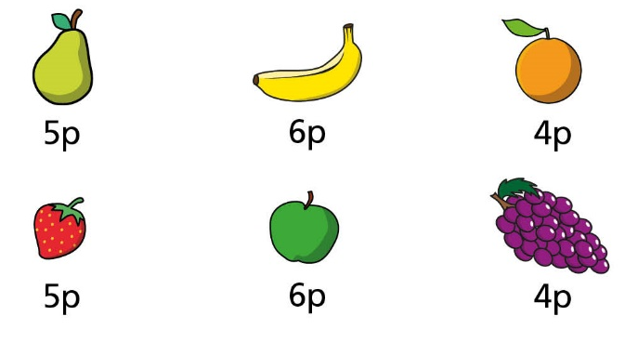
Here is some fruit.
Kim buys a banana and a strawberry.
How much does she spend? ________p
Ron buys grapes and an apple.
How much does he spend? ________p
Who spends the most money? ____________
Explain how you know.
______________________________________________________________________________________________
______________________________________________________________________________________________
______________________________________________________________________________________________

Here is some fruit.
Kim buys a banana and a strawberry.
How much does she spend? ________p
Ron buys grapes and an apple.
How much does he spend? ________p
Who spends the most money? ____________
Explain how you know.
______________________________________________________________________________________________
______________________________________________________________________________________________
______________________________________________________________________________________________

